Kubernetes Pods — Quick Notes

What is a Pod?
- Smallest deployable unit in Kubernetes.
- Wraps one or more containers that share network (same IP) and storage (volumes).
- Usually 1 container per pod; multi-container pods share localhost and volumes (e.g. sidecar pattern).
- Pods are ephemeral — they don't self-heal; a Controller (Deployment, ReplicaSet, StatefulSet, etc.) manages their lifecycle.

Diagram
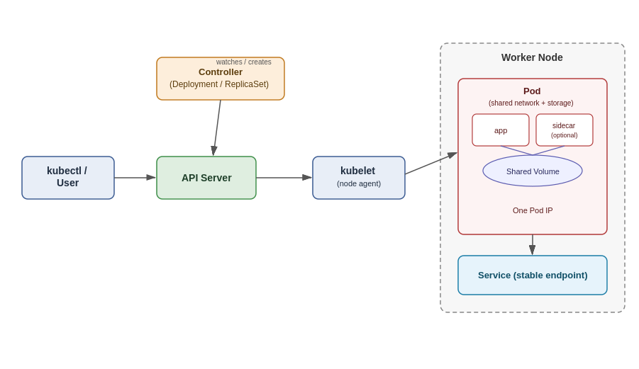

Pod Lifecycle (Phases)
Pending → Running → Succeeded / Failed (also Unknown if node unreachable)

Common kubectl Commands

Create / View
kubectl run mypod --image=nginx # create a pod quickly
kubectl apply -f pod.yaml # create/update from manifest
kubectl get pods # list pods
kubectl get pods -o wide # list with node/IP info
kubectl get pods -A # all namespaces
kubectl describe pod mypod # detailed info + events

Debug
kubectl logs mypod # view logs
kubectl logs mypod -c containername # logs of specific container
kubectl exec -it mypod -- /bin/bash # shell into pod
kubectl port-forward mypod 8080:80 # forward local port to pod

Manage
kubectl delete pod mypod # delete a pod
kubectl edit pod mypod # edit live pod (limited fields)
kubectl label pod mypod env=dev # add a label

Minimal Pod YAML
apiVersion: v1
kind: Pod
metadata:
name: mypod
labels:
app: myapp
spec:
containers:
- name: app
image: nginx:latest
ports:
- containerPort: 80

Key Points to Remember
- Pods are not self-healing — use a Deployment/ReplicaSet for resilience.
- Each Pod gets one unique IP in the cluster.
- Containers in the same Pod can talk via localhost.
- Use Services to expose Pods with a stable network identity.

Pods with yaml file

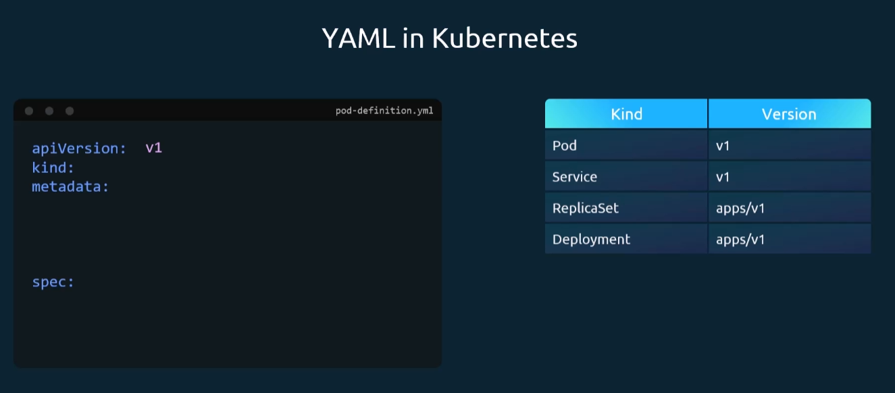

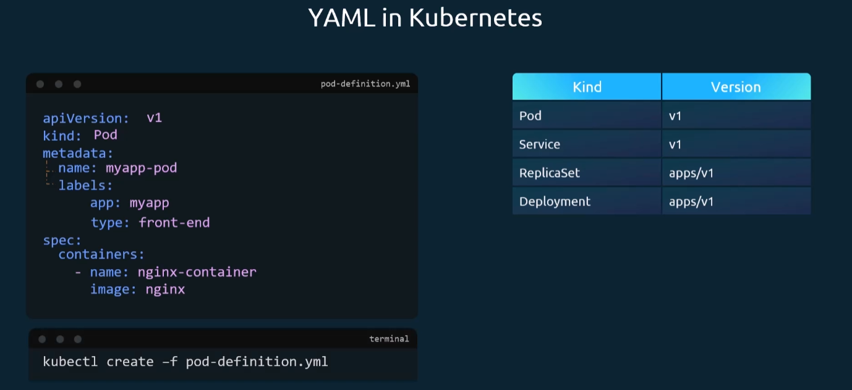

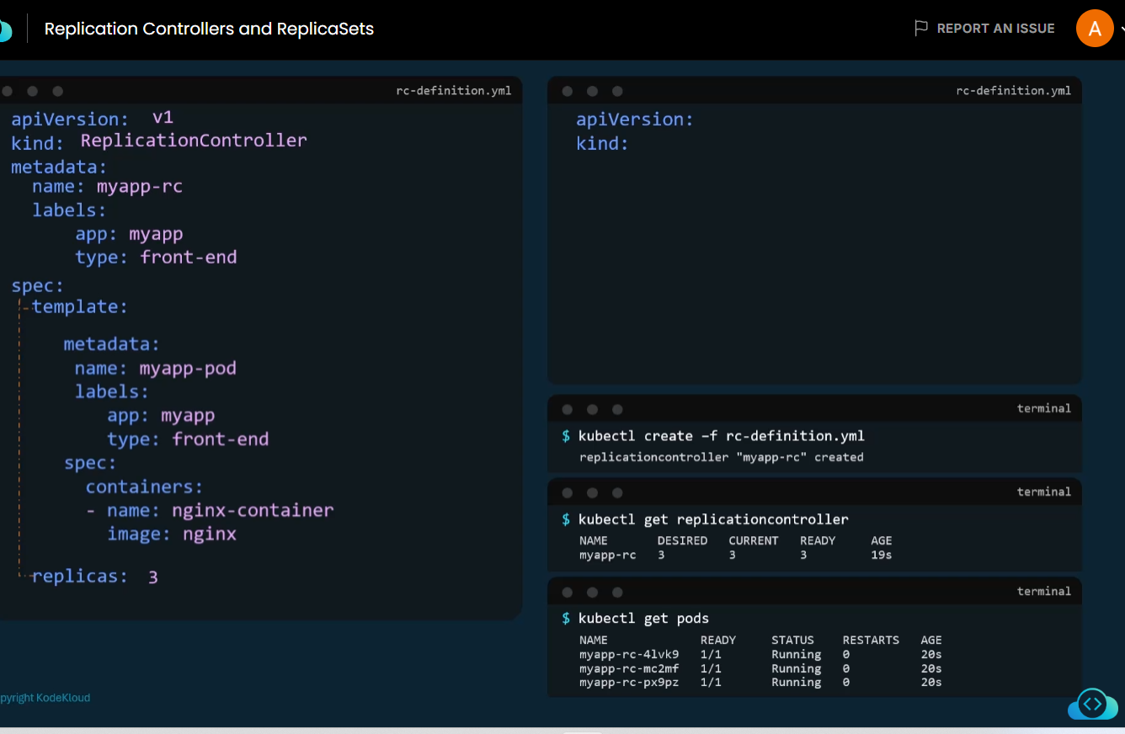

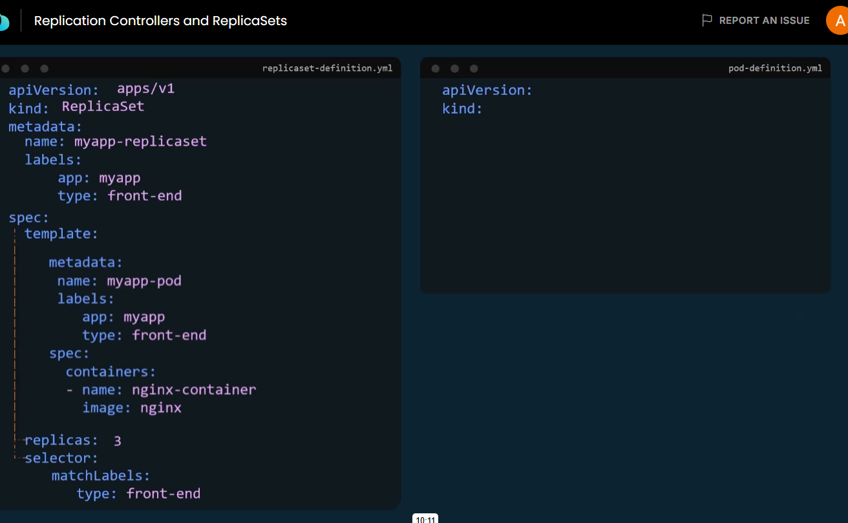

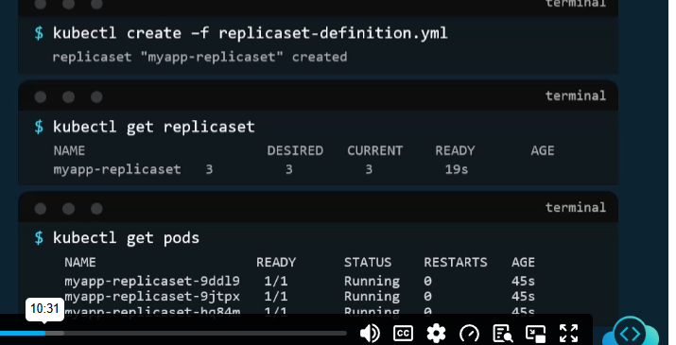

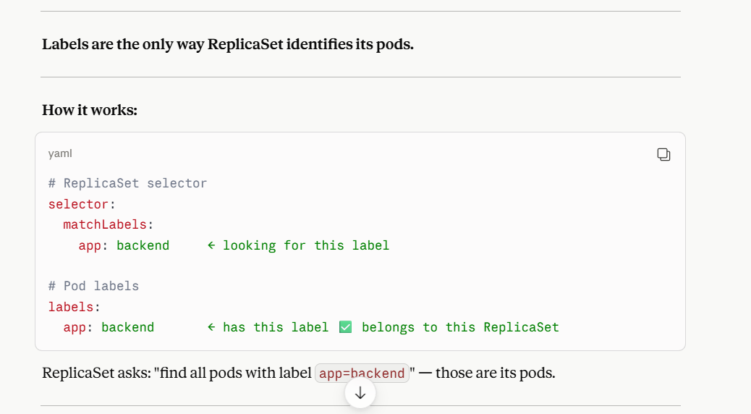

How can we scale number of Replicas?

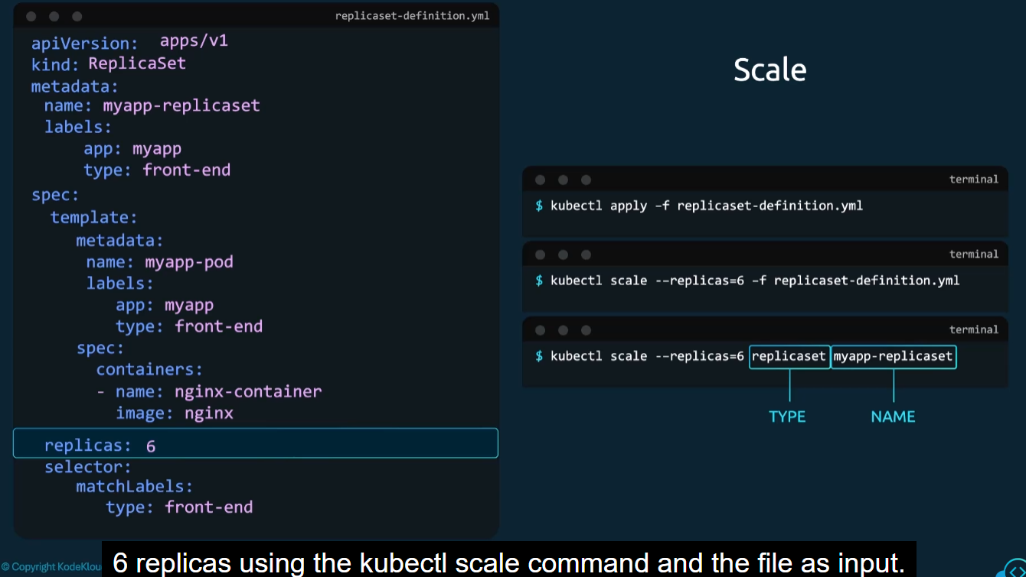

List of Replicaset
Kubectl get replicaset

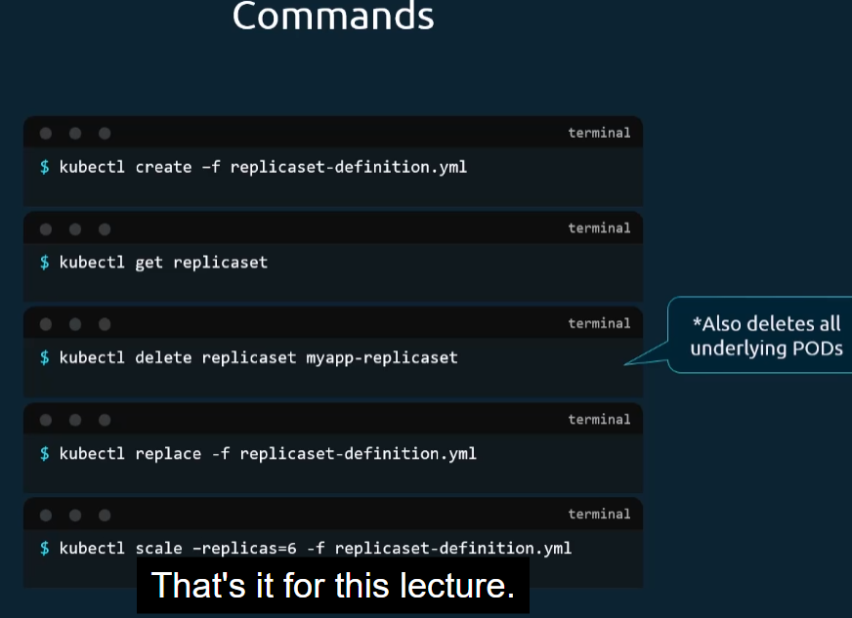

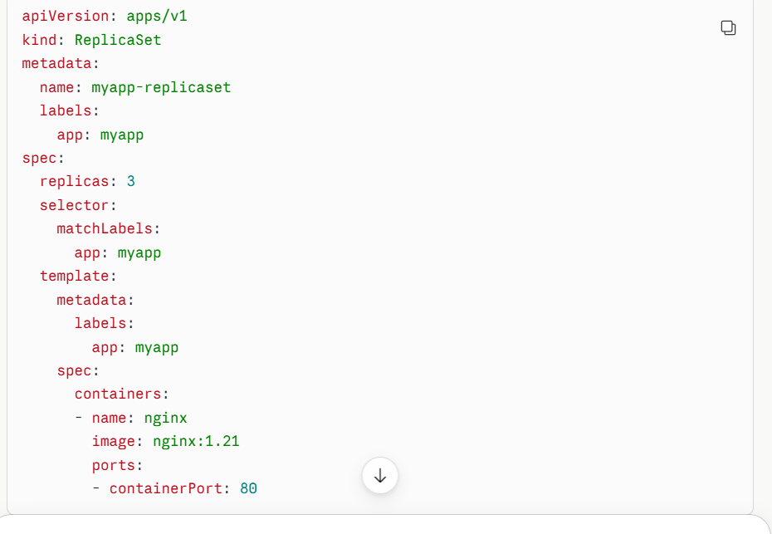

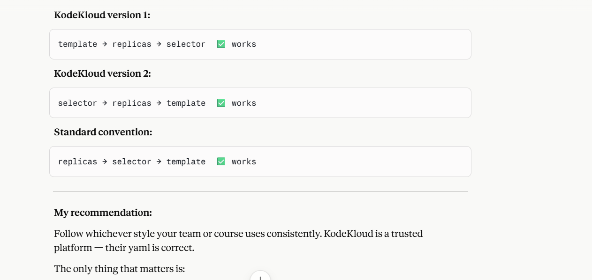What actually happens with low disk space:
- Kubelet monitors node conditions like DiskPressure.
- If the node runs low on disk (root filesystem or imagefs), kubelet marks the node DiskPressure=True.
- It then starts evicting pods to reclaim space — pod status shows Evicted, not CrashLoopBackOff.
- Reason is usually shown as Evicted — The node was low on resource: ephemeral-storage.
How to check it (not just app logs):
bash
kubectl describe pod <pod-name> # check "Status" and "Reason" fields
kubectl get events --sort-by=.lastTimestamp # look for Evicted/DiskPressure events
kubectl describe node <node-name> # check Conditions: DiskPressure, MemoryPressure
kubectl top node # quick resource usage snapshot
df -h # if you have node access, check actual di

"When a pod fails after running for a while, don't just check the application logs — also check node conditions and events, since low disk space (or memory) on the node can cause kubelet to evict or restart pods, not just app bugs."

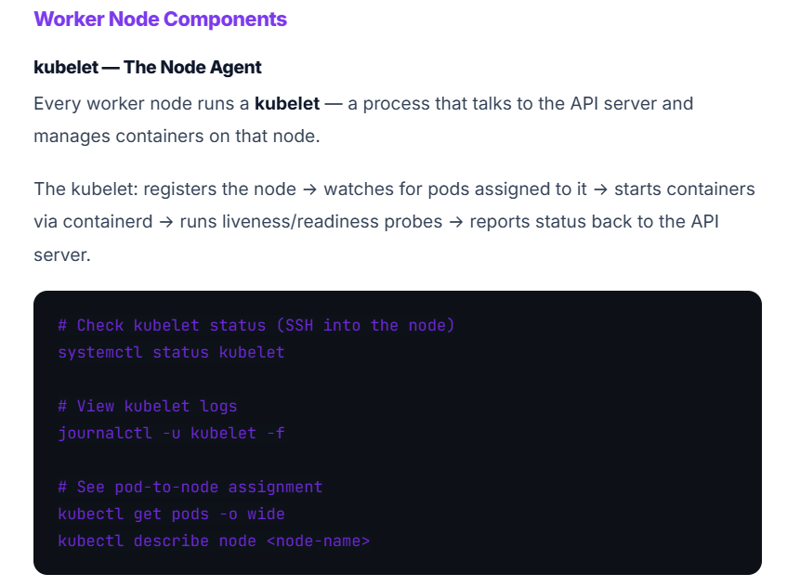

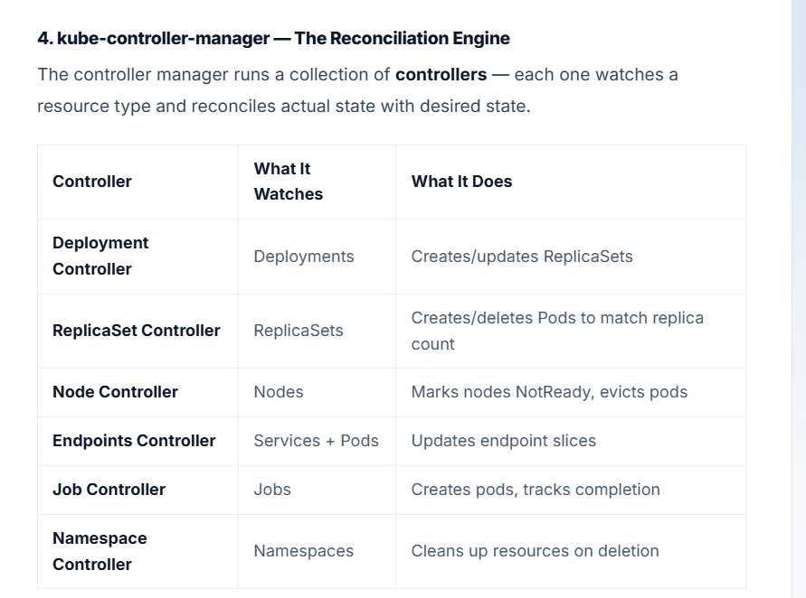

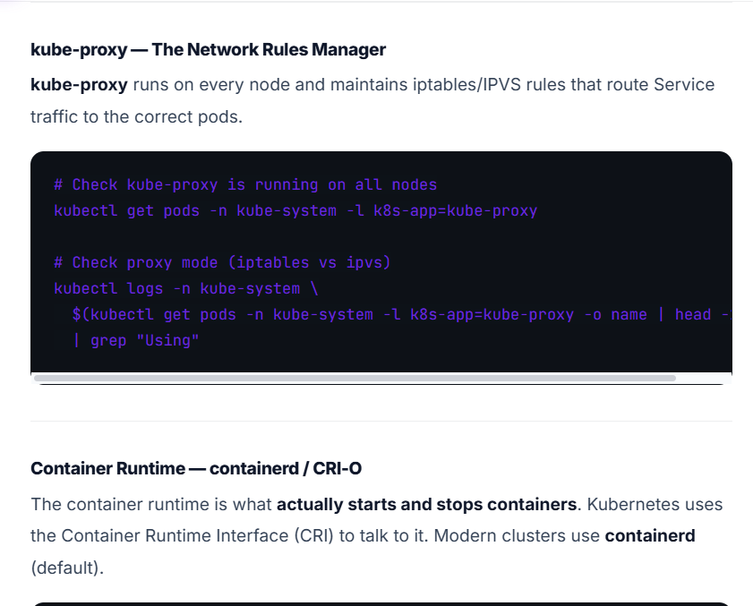

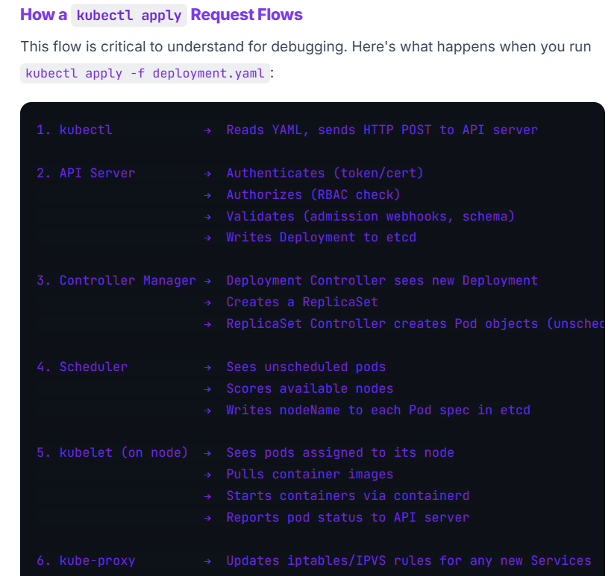

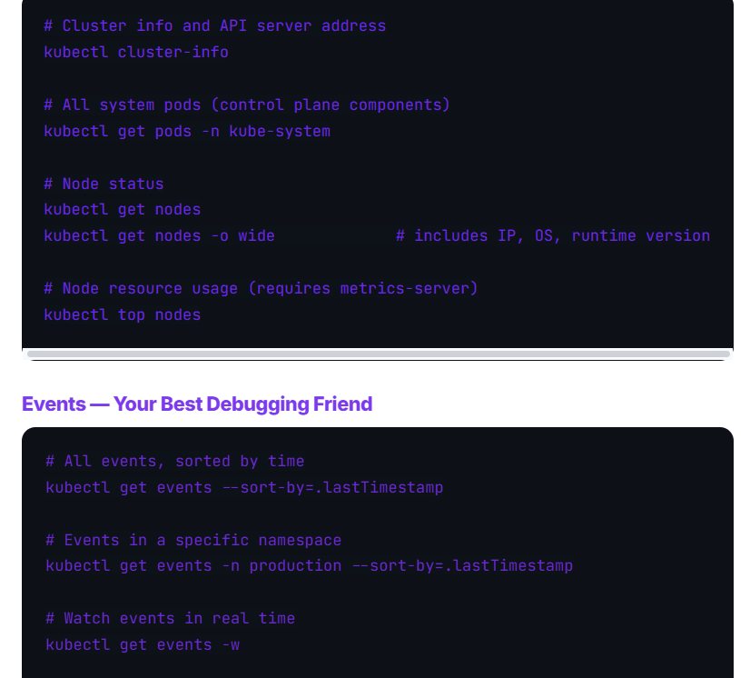

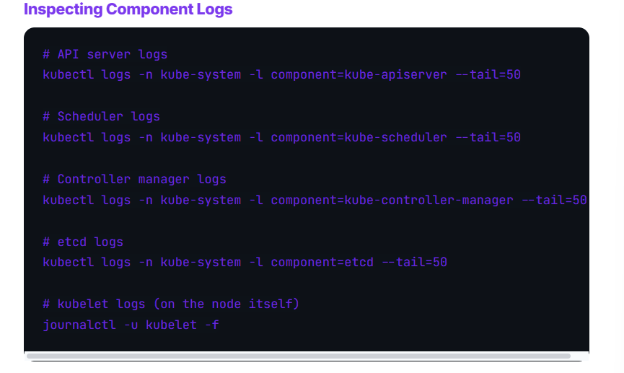

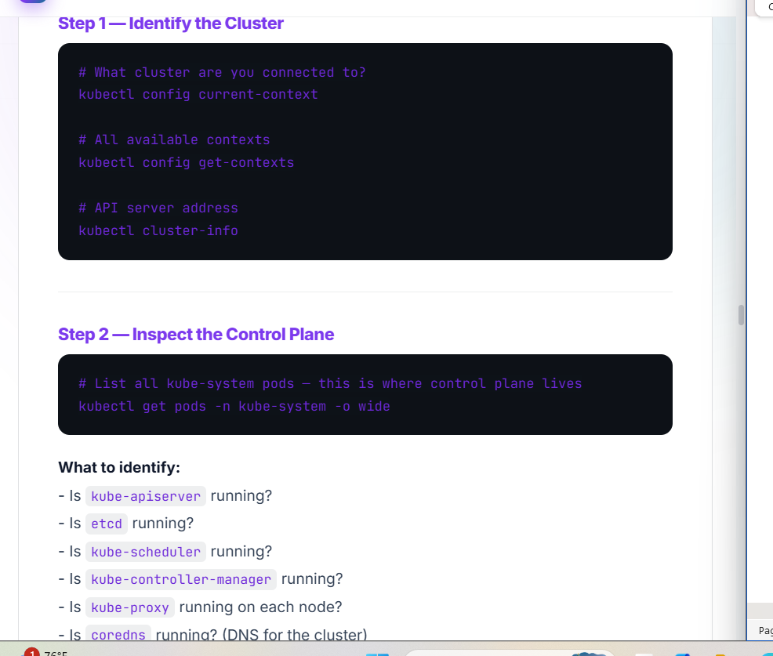

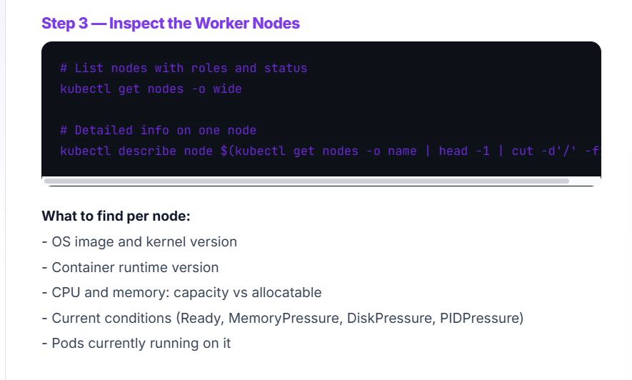

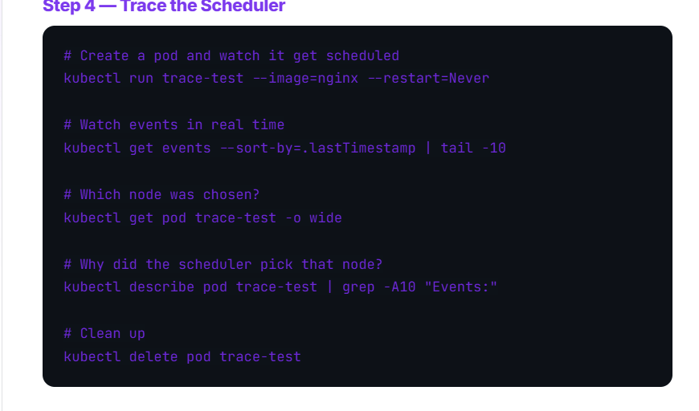

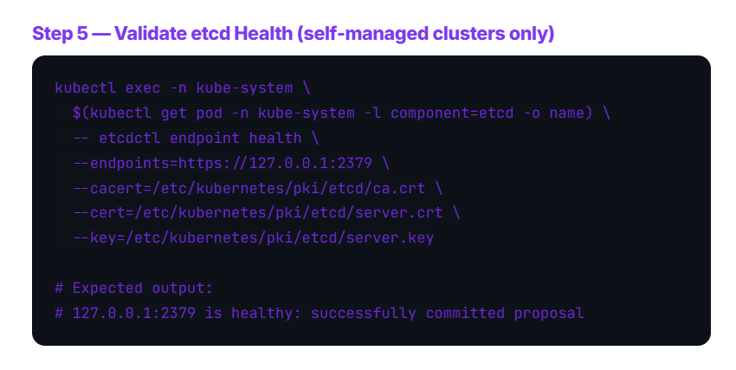

Multiple pods are deployed using replication controller and replica set

Deployment

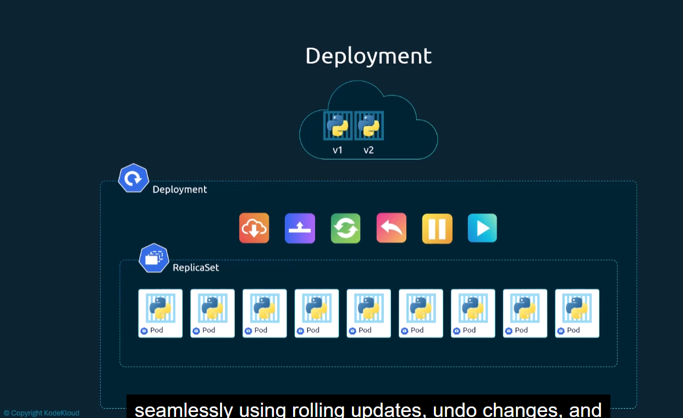

- create replica set
- rolling update undo , pause and resume changs

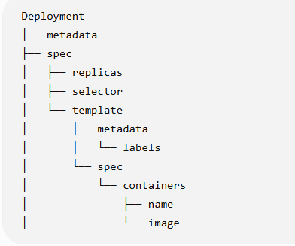

Kubcctl create – deployment-definition.yaml create deploymet

Kubectl get deployments to get all deployments

To get all components of Kubernetes at once
Kubectl get all command

Problem: Deployment did not accept the capital metadata name in Deployment yaml file

